QA Asssesment Task 1

Tools used :
Postman

Collection Link
Link of Published API Testing in Postman
https://documenter.getpostman.com/view/5015779/RzZFAvKc

All the breed

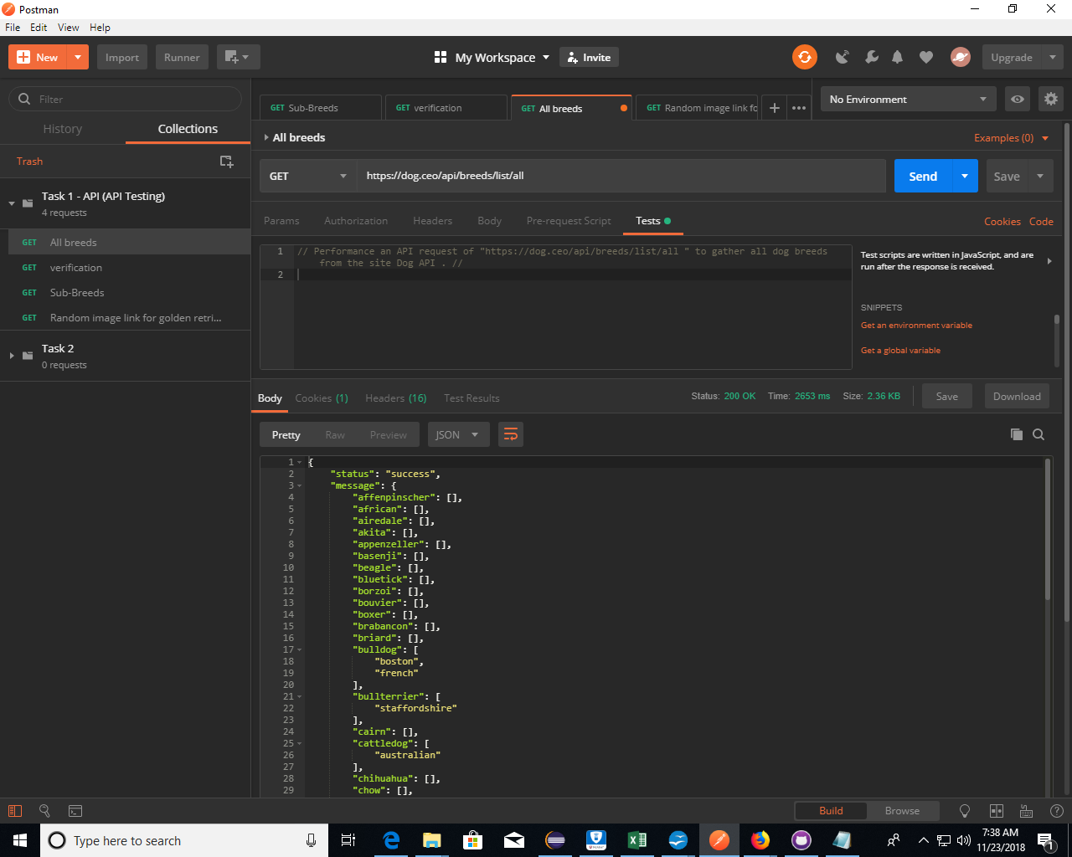

Verification
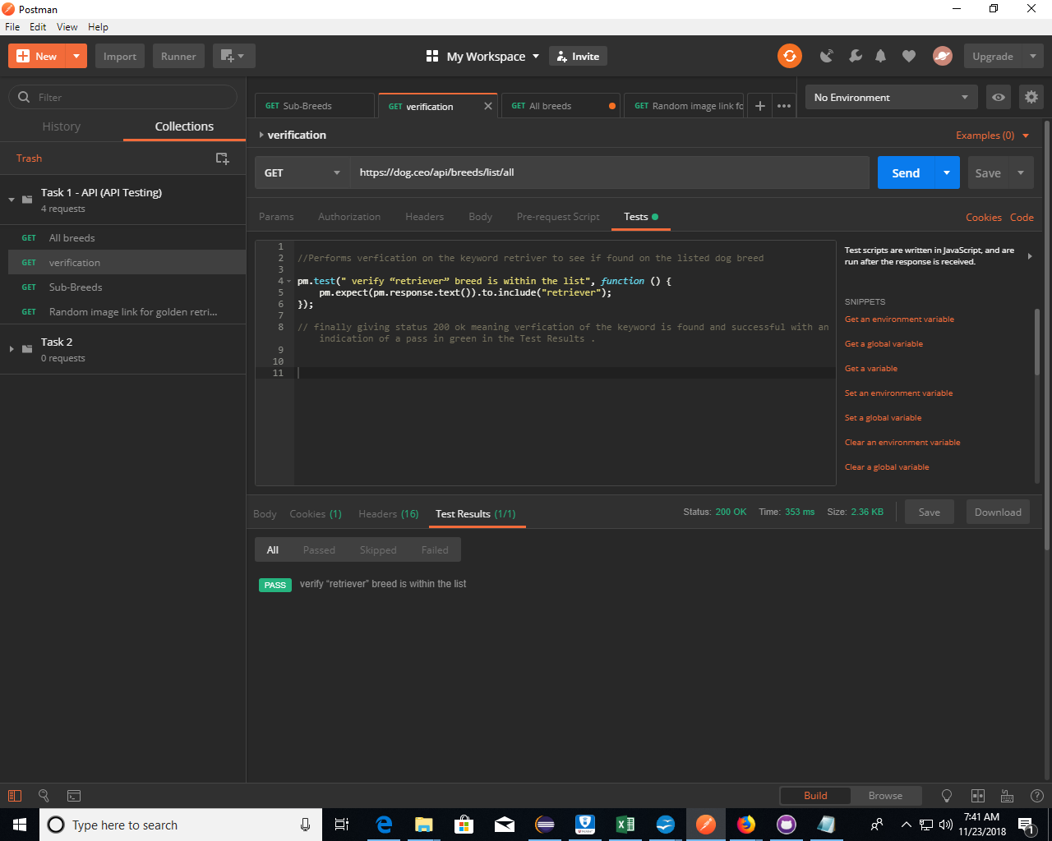

Sub Breed

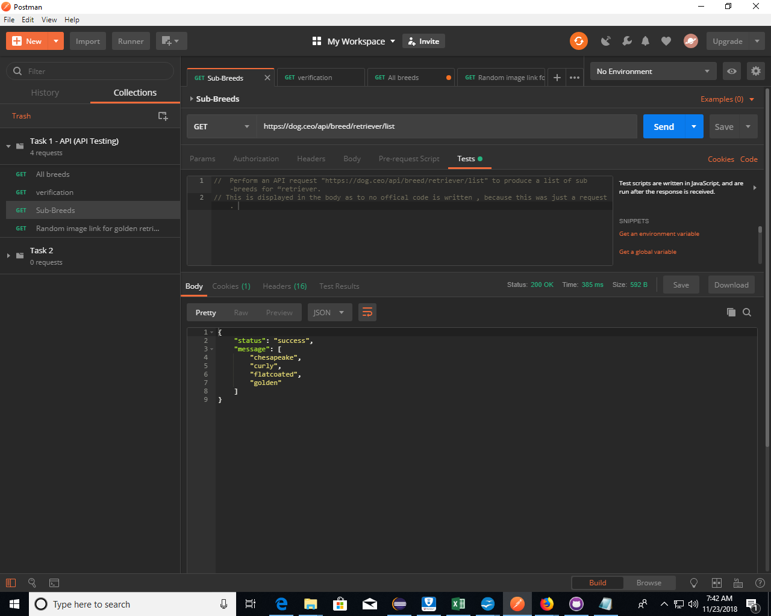
Random Image – Retriver “ Golden

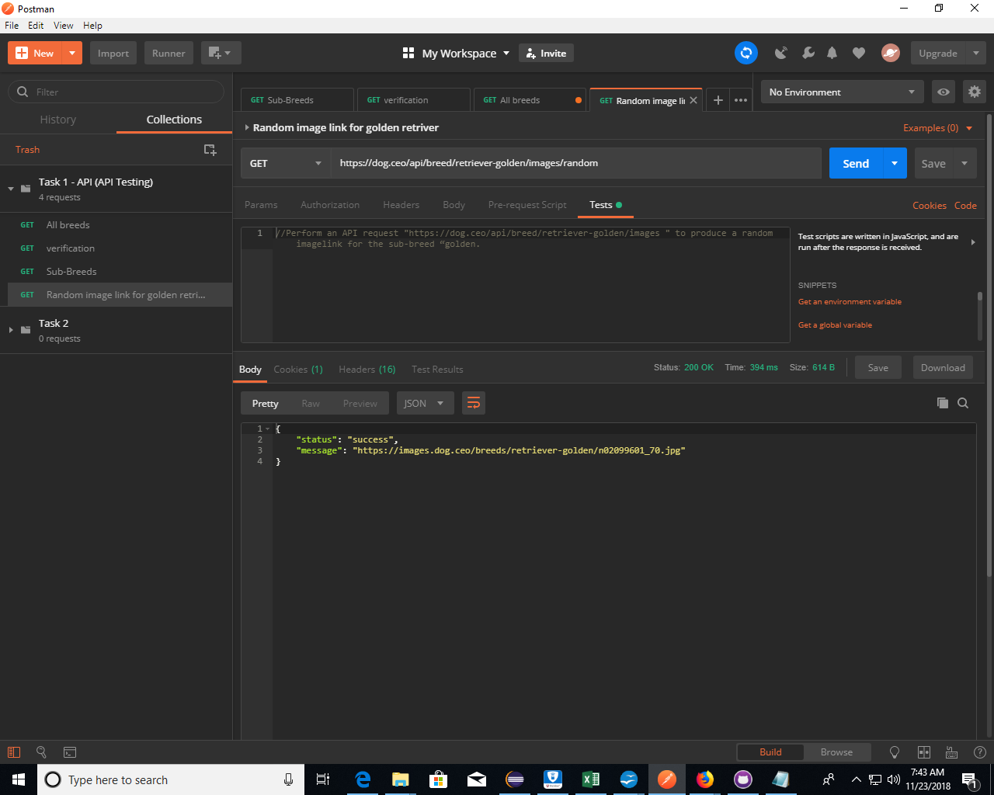

Running Published Test in Postman

